Weekend Activities at An Riocht: 
FRIDAY 1ST MAY
U10 Football 6.30pm @ Dunavil An Riocht v Atticall
No Cinema tonight
SATURDAY 2nd MAY
11am P1 & P2 Gaelic Practice; 12pm P3 & P4 Gaelic Practice
SUNDAY 3rd MAY
U12 Football 11am @ Dunavil An Riocht v Shamrocks
MONDAY 4th MAY
U10 Football 7pm in Longstone
TUESDAY 5th MAY
7pm U12 Gaelic Practice
WEDNESDAY 6th May
6.30pm U8 Camogie Practice; 7.30pm U10 & U12 Camogie Practice
Dates for Your Diary:
Date | Activity
Sat 2nd May | Sacrament of Holy Communion celebrated at 10.00am
Mon 4th May | Bank Holiday – School Closed
Sun 10th May | P7 Parish Ceremony at 9.00am mass
Mon 18th May | Sacrament of Confirmation at 4.00pm;  School closes at 12.30pm
Tuesday 19th May | P2/3 class assembly at 10.00am
Thursday 21st May | May Procession in honour of Our Lady at 1.00pm
Sat 23rd May | P7 notification of post-primary school placement
Mon 25th-Thurs 29th May | School Closed to Pupils
Friday 29th May | Provisional date for Sports Day

DRAMA Dates: GRANGE PRIMARY SCHOOL, KILKEEL
Please find below the dates of the Drama Club:

WEEK | DATE
 | 4th May - OFF
3 | 11TH May
 | 18th May - CONFIRMATION
 | 25TH May -OFF
4 | 1st June
5 | 8th June
6 | 15th June
7 | 22nd June - unconfirmed

Grange Primary School Website:
www.grangeprimaryschoolkilkeel.co.uk

SCHOOL CLOSINGS 2004/05

The following are the school closings for the school year 2004/05.
BBr
Autumn Mid-term Thursday 30 October 2004
Friday 31 October 2004
Monday 01 November 2004

Immaculate Conception Wednesday 08 December 2004
Christmas Vacation School clos M20 December 2004
School re-opens Friday 07 January 2005

Spring Mid-term Monday 14 February 2005

St Patrick’s Holiday Thursday 17 March 2005

Easter Vacation School closes Thursday 24 March 2005
School re-opens Monday 04 April 2005

Mayday Monday 02 May 2005

Spring Holiday Friday 27 May 2005
Monday 30 May 2005

Summer Vacation Sc closes Thursday 30 June 2005

These are the closings as we know them at this time.

Notification of any alterations will be given at the appropriate tim

We trust you will find this information useful.


Grange Newsletter
Vol 12Issue28
1st May 2015

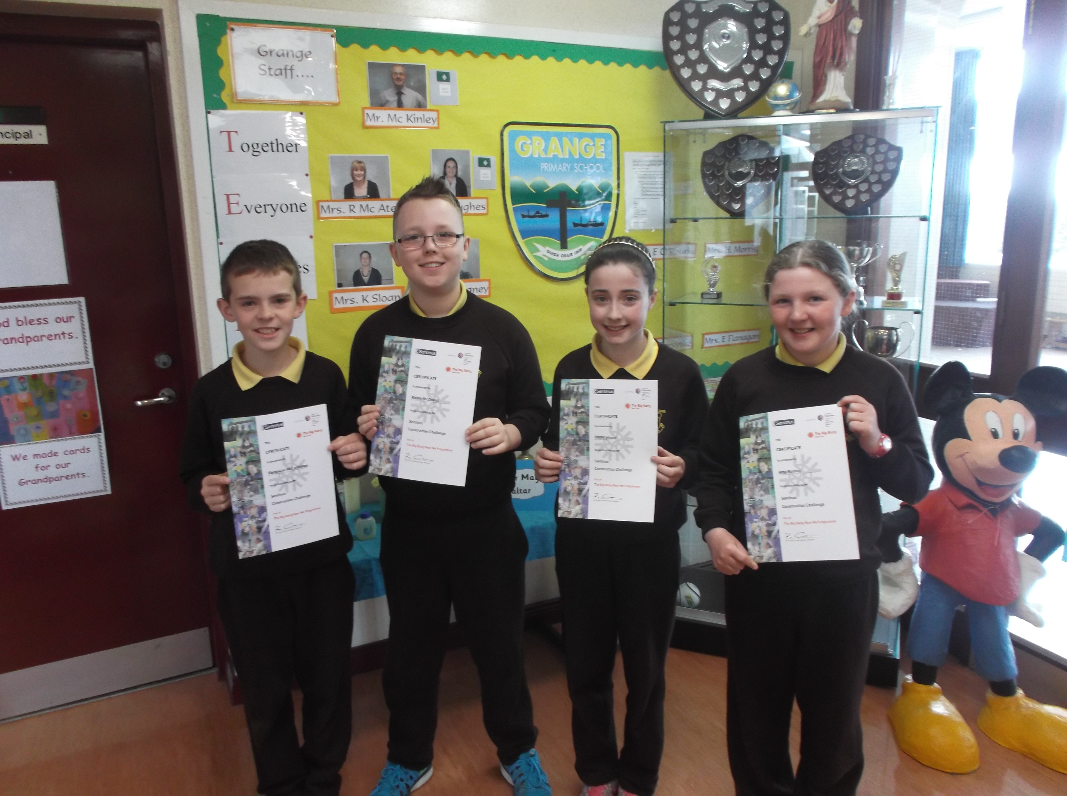
Well done to Gerry-Lee, Ronan, Hattie and Amy, who recently represented our school at a Young Innovators Sentinus Technology Challenge in St. Colman’s College, Newry.

Article 31:
Each child has the right to relax, play and take part in a wide range of cultural and artistic activities

May Day Bank Holiday:
Our school will be closed on Monday 4th May, giving our Holy Communion pupils their long weekend to celebrate their special day on Saturday.

Our school will be open as normal on Election Day 7th May.
Holy Communion – Saturday 2nd May 2015
The pupils in Primary 4 have been completing their final practices this week before Saturday’s Blessed Eucharist ceremony. All P4 families will have today received a letter detailing final arrangements for tomorrow.
We pray that the weather is favourable and that the children and their families enjoy this very special day in our school calendar.
Primary 3/4 Class Assembly:
Well done to our P3/4 class on their assembly last Monday. It is definitely a busy week for the P4 teacher & pupils. Our next assembly, involving the P2/3 class will be on Tuesday 19th May at 10.00am. (please note change of day)
Primary 7 Parish Ceremony:
The Primary 7 pupils, preparing to receive the Sacrament of Confirmation on 18th May will have their pre- Confirmation Parish Ceremony at the 9.00am mass in Grange on Sunday 10th May.
WHOLE SCHOOL ASSESSMENT:
During the month of May, each class from P1-P7 will be involved in various forms of assessment, to help in producing both diagnostic and summative data on each pupil’s academic performance in the key curriculum areas of Literacy & Numeracy. For the Primary 3 – 7 pupils, many of these tests are referred to as ‘Standardised Tests.’ In helping assist with the administration, consistency of whole school approach and test reliability, assessments involving children from Primary 3 upwards take place in the Assembly Hall. This can be a daunting experience for any child, especially the younger children and despite our best efforts to reassure them, some children can become nervous at the prospect and allow the whole thing to put them off. Others think it’s great. We use the hall because all children in a year group complete the test at the same time and this assists with the administration. Each teacher will ensure children are given appropriate instruction and there is really no time limit to completing the assessments. We therefore ask that each parent has a chat with their child in relation to simply listening to their teacher’s instructions and trying their best. All details/ instructions will be gone over a number of times in each class before the children proceed to the hall.
Parents will receive information from the outcomes of these assessments in their child’s ‘Pupil Profile Report’ at the end of June and also in a Stanine Report Sheet that will accompany the report.

What we try to ensure is that each child gets the opportunity to complete these assessments in a happy and relaxed manner, as a natural aspect of their daily school work, and to allow them to perform to the best of their ability. If your child expresses any undue level of anxiety in relation to our assessment procedure, please contact school and speak with your child’s teacher in relation to the matter.
P7 Personal Development Presentation:
A Personal Development presentation for P7 children took place Thursday of this week. We ask that parents use this opportunity to initiate a conversation with their child in relation to matters discussed. We commend the P7s on their maturity in relation to the programme.
Cycling Proficiency:
The Primary 7 children have been informed about this year’s programme for Cycling Proficiency.
Session 1: Thursday 30th April;
Session 2: Tuesday 5th May;
Session 3: Tuesday 12th May;
Session 4: Wednesday 20th May.
Each session occurs from 2.00pm – 3.45pm.
As per the letter issued to all those looking to participate, each child must have a roadworthy bicycle, a helmet and attend all the sessions of the programme.
Football at an Riocht:
Well done to the boys and girls who participated in the mixed team Gaelic football tournament in An Riocht last Friday.
Cumann na mBunscoil:
Well done to Tyler Shepcar who attended a Gaelic Skills event in Annsborough on Wednesday, where he was selected to play in the half-time school’s match during the Derry v Down Ulster Championship match in Celtic Park on 7th June.
Parent Governor:
On Monday last, each family should have received a letter requesting nominations from parents to take up the role of parent representative to the present Board of Governors. The closing date for return of completed Nomination Forms is 12noon on Friday 8th May. Following the close of nominations, (if there are a number of nominees) parents will receive a Ballot paper detailing the names of all nominess, where they will be asked to vote accordingly. If any parent has any questions to ask in relation to this matter, please contact the Principal, Mr. Mc Kinley.
Grand Opera House Panto-2016:
Our present P3-6 pupils were today given a note asking them to confirm their desire to attend next year’s Pantomime in The Grand Opera House in January 2016. Similar to this year, we anticipate the cost to be around £15 per pupil. We will look for a £10 deposit in early September with the reaminder to be paid by the end of November. The 2015-16 panto is Snow White & The Seven Vertically Challenged Individuals.
End of Year Trips:
Children will shortly receive details of our end of year outings.
After School Clubs / Football at the Kingdom:
Coaching for any pupils(boys and girls) in Primary 3 and 4 will commence on Wednesday 6th May up an An Riocht. Children are asked to ensure they bring appropriate clothing for outdoor activity. If it is too wet/cold, sessions will be held in the hall. Children are to be picked up at 4.00pm sharp.
Lights, Camera, Confidence Drama Club:
There is no Drama Club next Monday. Week 3 will take place on 11th May.

