Dates for Your Diary:
Date | Activity
Mon 18th May | Sacrament of Confirmation at 4.00pm;  School closes at 12.30pm.
Tuesday 19th May | P2/3 class assembly at 10.00am
Thursday 21st May | May Procession in honour of Our Lady at 1.00pm
Sat 23rd May | P7 notification of post-primary school placement
Mon 25th-Thurs 29th May | School Closed to Pupils
Thursday 28th May | Induction Day for St. Louis Year 8s in September
Friday 29th May | Sports Day
Tuesday 2nd June | Kilbroney Primary Schools’ Cross-country event
Friday 5th June | St. Mark’s High School Induction Day – Year 8s
Tuesday 9th June | Grange Primary School Musical Evening 7.30pm
Thursday 11th June | Prospective Primary 1 Induction Day – 2.00pm
Monday 15th June | Environmental Beach Clean – Greencastle – 10.00am
Thursday 18th June | Kilkeel Primary School Asthma Sports event -10.00am
Friday 19th June | St.Columban’s High School Induction Day – Year 8s
Tuesday 23rd June | End of Year Leavers’ Mass - 10.00am
Wednesday 24th June | Primary 1-4 Trip to Castlewellan
Thursday 25th June | Primary 4-7 trip to Lisburn
Tuesday 30th June | School closes for summer at 12.00noon

DRAMA Dates: GRANGE PRIMARY SCHOOL, KILKEEL
Please find below the dates of the Drama Club:
WEEK | DATE
 | 18th May - CONFIRMATION
 | 25TH May -OFF
4 | 1st June
5 | 8th June
6 | 15th June
7 | 22nd June - unconfirmed

CASH FOR CLOBBER:

LAST DAY FOR BRINGING IN YOUR CLOBBER IS NEXT MONDAY,
MONDAY 18TH MAY
PLEASE GET YOUR BAGS IN AS SOON AS POSSIBLE.

Grange Primary School Website:
www.grangeprimaryschoolkilkeel.co.uk

SCHOOL CLOSINGS 2004/05

The following are the school closings for the school year 2004/05.
BBr
Autumn Mid-term Thursday 30 October 2004
Friday 31 October 2004
Monday 01 November 2004

Immaculate Conception Wednesday 08 December 2004
Christmas Vacation School clos M20 December 2004
School re-opens Friday 07 January 2005

Spring Mid-term Monday 14 February 2005

St Patrick’s Holiday Thursday 17 March 2005

Easter Vacation School closes Thursday 24 March 2005
School re-opens Monday 04 April 2005

Mayday Monday 02 May 2005

Spring Holiday Friday 27 May 2005
Monday 30 May 2005

Summer Vacation Sc closes Thursday 30 June 2005

These are the closings as we know them at this time.

Notification of any alterations will be given at the appropriate tim

We trust you will find this information useful.


Grange Newsletter
Vol 12Issue30
15 May 2015

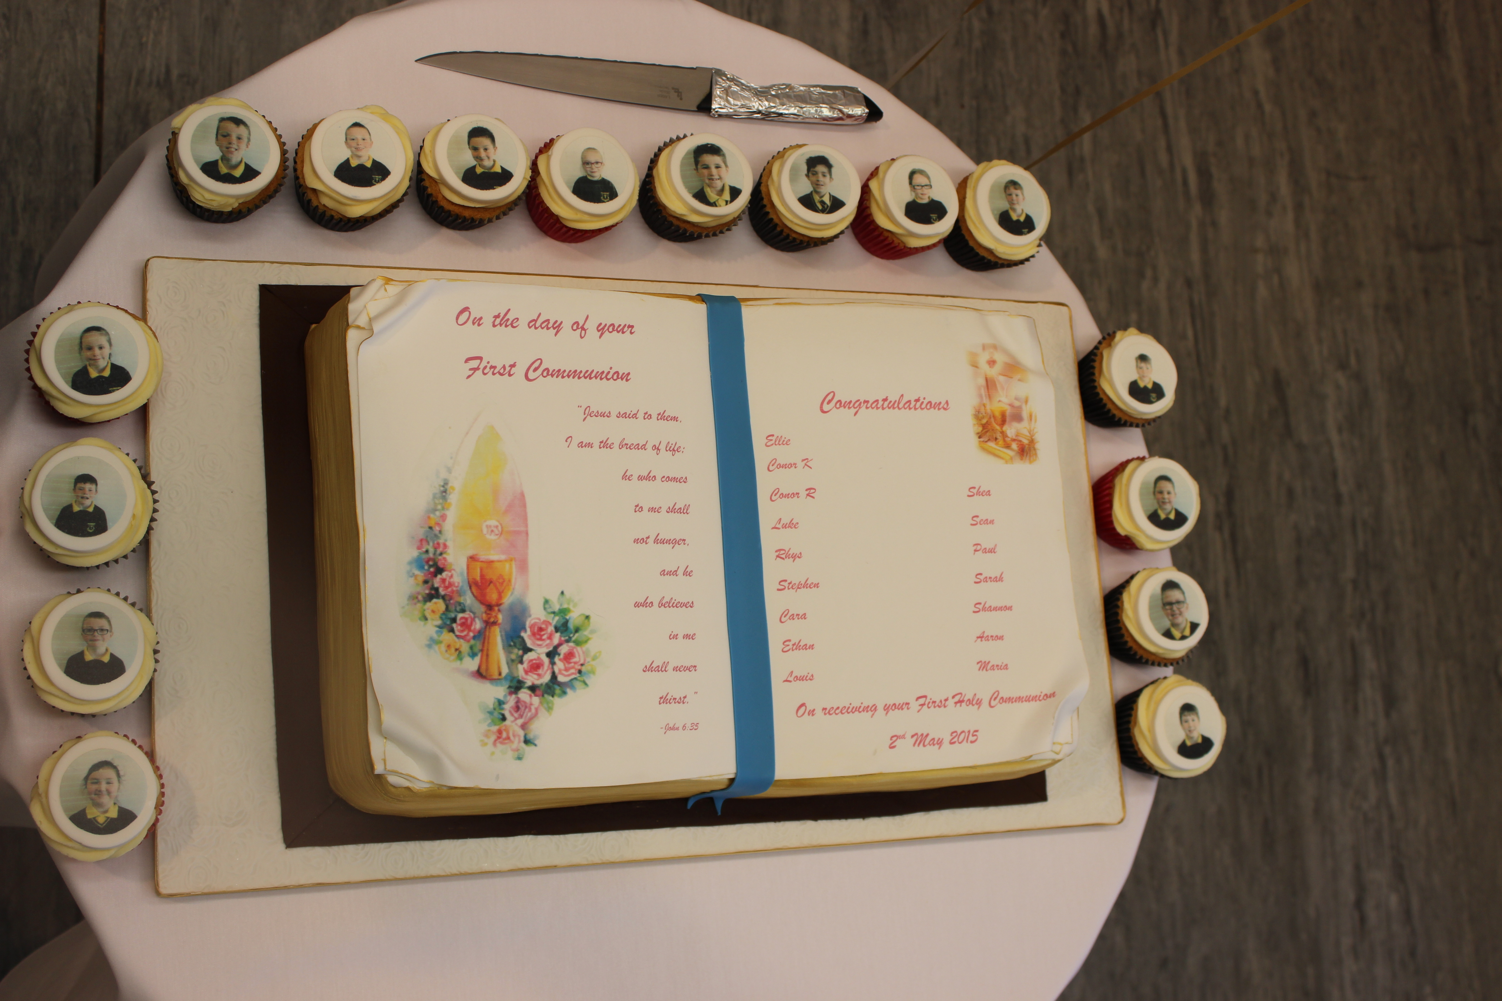
Just a reminder of the work that went into our Holy Communion day.
Article 14:
Each child has the right to think and believe what they want and be free to practise their religion, as long as it doesn’t stop other people from enjoying their rights.

Confirmation:
We celebrate the Sacrament of Confirmation in the parish on Monday 18th May at 4.00pm in Massforth. On this day, school will close for all pupils at 12.30pm, following lunch. Rooney Bus pupils will be transported home at this time. There will be No Ulsterbus at 12.30pm.

All choir members have been invited to assist with the ceremony.They are asked to be in Massforth at 3.30pm at the latest.

Those children playing the tin whistle are asked to be in the chapel earlier for a practice at 3.15pm.
Primary 7 Parish Ceremony:
Well done to The Primary 7 pupils who celebrated their ‘Called By Name ‘ Parish Ceremony at last Sunday’s mass in Grange. We wish them well for Monday’s Confirmation ceremony.
Parent Governor:
All parents should have received a Ballot Paper detailing the names of the nominees to the position of Parent Representative. Both parents are entitled to vote. Please place a single tick in the box beside the name of the parent you wish to elect and return to school in the envelope marked ‘Clerk of Elections’. Close for receipt of votes is Friday 22nd May. Further to this date, the clerk, Mr. Sean Rogers will contact nominees to arrange a date for the counting of votes. If any parent has any questions to ask , please contact the Principal, Mr. Mc Kinley.
Klbroney Cross Country:
This year’s event takes place on Tuesday 2nd June at 10.00am in Kilbroney Park. The event is open to boys and girls from Primary 4-7. Children wishing to attend will need to show their ability to complete the distance and also be able to be brought to and from the event on the day.
Sports Day 2015:
Our annual ‘Alternative Sports Day’ is scheduled to take place on Friday 29th May, up at An Riocht, from 10.00am. As previously, all the children have been split into TEAMS with this year’s theme being The Irish Open, coinciding with it being held at The Royal County Down at the same time. We ask that each Team Leader has a chat with their team and that together they decide on a colour of garment for their team and to find out a little about their’golfer’ who they will be representing.
ECO- Schools Beach Clean:
We have a Sponsored Environmental Beach Clean scheduled to take place on Monday 15th June. This week, each child received an explantory letter and Sponsor Form to assist with the activity.Similar to last year, we are hoping as many of our adult ‘volunteers’ will be able to assist us on the day. Many thanks to all those who have already raised some funds for this event.
End of Year Trips:
All children should have received notification of the details of their end of year trip. We ask that payment for these is eith us before the end of next week.

Tempest Photography:
We ask that all orders / payments for the recently taken Tempest photos are sent in to school as detailed and enclosed in the accompanying envelope on/before Friday 22nd May. We need to stick to this order schedule to allow for all orders to be processed in early June.
Post Primary School Notification:
All P7 parents this week received a letter notifying them of the arrangements by which they are notified of their child’s placement for September 2015. There are specific details in the letter in relation to ‘contingency arrangements’ in place on Saturday 23rd May, if parents fail to receive a letter in the post.
Primary 2/3 Assembly:
The next assembly, presented by the P2/3 class will take place on Tuesday coming, 19th May at 10.00am. Parents and family members are warmly invited to attend. (Please note change of day)
After School Clubs / Football at the Kingdom:
We had 9 participants for this week’s P3/4 & 5 football coaching with Turlough at An Riocht. We would definitely hope for an increaed number of participants over the next few weeks. Children are asked to ensure they bring appropriate clothing for outdoor activity. If it is too wet/cold, sessions will be held in the hall. Children are to be picked up at 4.00pm sharp.
Cumann na mBunscol:
We had a panel of players attend an inter schools 7-a-side qualifying event last Friday morning up at an Riocht for 7 -a - side schools in Down. The competition was very strong with 6 schools all playing 5 games against each other. The top 2 teams to qualify were Moneydarragh and Finnis.
Grand Opera House Panto-2016:
Our present P3-6 pupils were recently given a note asking them to confirm their desire to attend next year’s Pantomime in The Grand Opera House in January 2016. Similar to this year, we anticipate the cost to be around £15 per pupil. We will look for a £10 deposit in early September with the reaminder to be paid by the end of November. The 2015-16 panto is Snow White. Please return replies in order to allow us to purchase tickets for all those looking to attend.
Ulster Orchestra Performance:
Faithful choir members will have received notification of our plans to attend this event on Wednesday 3rd June. Please return Permission Slips asap.
May Procession:
We plan to hold a May Procession from within the school grounds and proceeding to Our Lady’s grotto in the chapel grounds. The procession will take place on Thursday 21st May, beginning at 1.00pm, involving all our classes. Any adults who would like to join us are most welcome.
Lights, Camera, Confidence Drama Club:
Week 4 of the Drama Club will take place on Monday 1st June.
Cycling Proficiency:
Pupils contnue to participate in this scheme as per timetable.

