Dates for Your Diary:
Date | Activity
Friday 5th June | St. Mark’s High School Induction Day – Year 8s
 | St. Colman’s Mourne Schools Netball competition
Tuesday 9th June | P5 Mourne Mountains Workshop
Wednesday 10th June | Gaelic Fun event at An Riocht from 10.00am.
 | Grange Primary School Musical Evening 7.30pm
Thursday 11th June | Prospective Primary 1 Induction Day – 2.00pm
Friday 12th June | P6 TIMMS study.
Monday 15th June | Primary 1 End of Year assembly, 10.00am
Wednesday 17th June | Term 3 House Point Winners cinema outing
Thursday 18th June | Kilkeel Primary School Asthma Sports event -10.00am
Friday 19th June | St.Columban’s High School Induction Day – Year 8s
Monday 22nd June | Environmental Beach Clean – Greencastle – 10.00am
Tuesday 23rd June | End of Year Leavers’ Mass - 10.00am
Wednesday 24th June | Primary 1-4 Trip to Castlewellan
Thursday 25th June | Primary 4-7 trip to Lisburn
Tuesday 30th June | School closes for summer at 12.00noon
Wednesday 1st July | Best Day of The Year

DRAMA Dates: GRANGE PRIMARY SCHOOL, KILKEEL
Please find below the dates of the Drama Club:
WEEK | DATE
5 | 8th June
6 | 15th June
7 | 22nd June - unconfirmed

Derry v Down Ulster Championship – Sunday 7th June:

Best of luck to Tyler Shepcar who will represent our school, playing for the Down Primary School’s team during half-time of the Senior game.
A good weekend for an anniversary?

.

Grange Primary School Website:
www.grangeprimaryschoolkilkeel.co.uk

SCHOOL CLOSINGS 2004/05

The following are the school closings for the school year 2004/05.
BBr
Autumn Mid-term Thursday 30 October 2004
Friday 31 October 2004
Monday 01 November 2004

Immaculate Conception Wednesday 08 December 2004
Christmas Vacation School clos M20 December 2004
School re-opens Friday 07 January 2005

Spring Mid-term Monday 14 February 2005

St Patrick’s Holiday Thursday 17 March 2005

Easter Vacation School closes Thursday 24 March 2005
School re-opens Monday 04 April 2005

Mayday Monday 02 May 2005

Spring Holiday Friday 27 May 2005
Monday 30 May 2005

Summer Vacation Sc closes Thursday 30 June 2005

These are the closings as we know them at this time.
Article 17:
Every child has the right to reliable information from the media. Governments must protect children from materials
that could harm them.
customs and religion of their family.
Notification of any alterations will be given at the appropriate tim

We trust you will find this information useful.


Grange Newsletter
Vol 12Issue32
05 June 2015

Well done to Ms Murphy’s class who were winners after taking part in the Ulster GAA Healthy Hamper competition. They were required to create a short animated movie promoting healthy eating. Here they are with their teacher Ms L Murphy receiving their prizes from Ulster GAA coach Mr Gareth Thornton
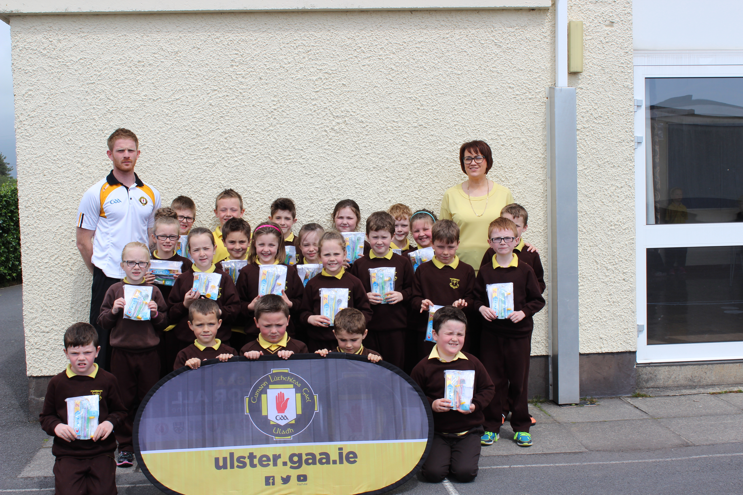

SPORTS DAY:
We had the luck of the gods last Friday as we had a dry day to enjoy our annual Sports Day.
Proceedings kicked off with our ‘Team’ events with all the children engaging in a wide range of activities requiring various levels of skill and teamwork, carefully monitored by our eager and invaluable volunteers, giving instructions, support and keeping a tally of the scores.
Following a short lunch, the serious competition got underway with the sprint, sack and egg & spoon races with our pupils, along with races for some of our prospective pupils and some other ‘BIG’ children also.
Once again, the children enjoyed a great day and we would like to take this opportunity to thank Joe and the staff at ‘The Kingdom’ for the continued use of their facilities; to our parent helpers again for assisting with our team events in the morning; to Turlough for his culinary skills; to Denise, Linda and the Friends of Grange members who provided the ice-lollies at the end of the day; and finally to our staff for organising and co-ordinating the day’s events.
Reporting to Parents 2015:
Pupil Profile End of Year reports will be sent home with pupils on Tuesday 23rd June, the day of our End of Year Leavers’ Mass. Accompanying the report will be a ‘Parent Reply Slip’. We ask parents to use this to acknowledge the report and provide any feedback as appropriate.
Primary 1 Assembly:
Our final assembly of the year, the Primary 1 assembly will take place on Monday 15th June at 10.00am. We hope to see as many of our P1 parents and family members as possible on the morning.
Primary 1 2015 Induction meeting:
Our Induction meeting for parents and their children, due to start school in September 2015, will take place on Thursday 11th June at 2.00pm.
Klbroney Cross Country:
This year’s event was another very frenetic and competitive one with over 30 schools involved on the day. Well done to all the children who participated on the day. Our top performers were Caitlin Harper, who finished 4th in the P5 Girls’ race and Conor Kelly who finished 6th in the P4 Boys’ Race.
Swimming:
Our swimming lessons for this year will end next week, on Thursday 11th June.
ECO- Schools Beach Clean:
Please note that we now plan to have our Sponsored Environmental Beach Clean now on Monday 22nd June. Last week, each child received an explantory letter and Sponsor Form to assist with the activity. Many thanks to all those who have already raised some funds for this event. We hope all our volunteers are able to help out on this rescheduled day.
Friends of Grange Meeting:
At last Monday’s meeting, final plans were put in place for a major school fundraising venture in October 2015. Details will be provided to parents shortly.
Primary 6 TIMMS survey:
P6 parents will have this week received information relating to an international based assessment being administered to P6 pupils on Friday 12th June.
Live to Play:
A group of P4 pupils were invited to a Fundamentals Fun Day in Pairc Esler, Newry, this morning. We hope they enjoyed themselves.
Post-Primary School Transfer Talk:
On Thursday, Mrs Maura Ward, our Education Welfare Officer, visited school to talk with the Primary 7 pupils about their transition from primary to secondary education. We thank Maura for her assistance again this year.
Tempest Photography:
Any orders for the P1, 2 or 7 group photos must be in school on the morning of Monday 8th June. They will be sent away at lunchtime on this day.
Altar Servers:
Existing Altar servers will be given a letter on Monday to ascertain their willingness to continue to serve from October coming.
The Primary 4 children will also each receive a letter inviting them to become servers in the new school year.
After School Clubs / Football at the Kingdom:
Coaching up at ‘The Kingdom’ has now ended for this year. We are indebted to Turlough and the staff who have provided the coaching this year.
Ulster Orchestra Performance:
Well done to our faithful choir members who attended a performance in Newry Sports Centre on Wednesday. We hope they enjoyed the experience.
Lights, Camera, Confidence Drama Club:
Week 5 of the Drama Club will take place on Monday 8th June.
Kilkeel Asthma Sports:
Based on our own Sports Day, letters of invitation will be given out next week to specific P1-7 pupils , inviting them to represent our school at the annual Kilkeel Asthma Sports Day activities on Thursday 17th June.
Netball:
Our senior girls participated in a netball tournament in St. Colman’s PS today.

Musical Pathways Concert:
We ask that all parents attending the event on Tuesday evening return the requests for tickets to allow for seating to be arranged.
Gaelic Fun Day:

We will hope to have a number of pupils from P3-7 participate in a Fun Day of activities up at An Riocht next Thursday. First preference will be given to those pupils who participated on Wednesday afternoons. This is due to take place next Wednesday.

